MID Topics
1. Basics of C
Problem 1: Write a C program to display your name, ID and department.
Solution:
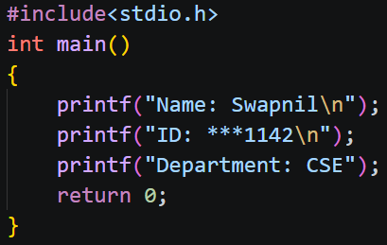

Problem 2: Write a C program to calculate the sum and average numbers.
Solution:
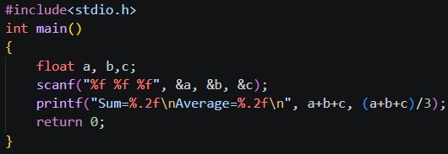

2. First C Program
Problem 1: Write a C program to print “Hello World!”.
Solution:
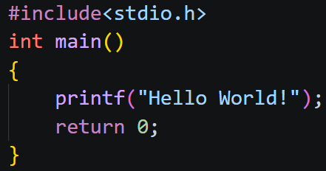

Problem 2: Write a C program to print your name and “Welcome to C Programming” on separate lines.
Solution:
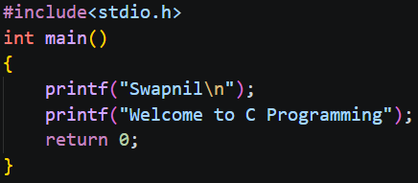

3. Compilation Process in C
Problem 1: Write a C program and compile and execute it using GCC.
Solution:
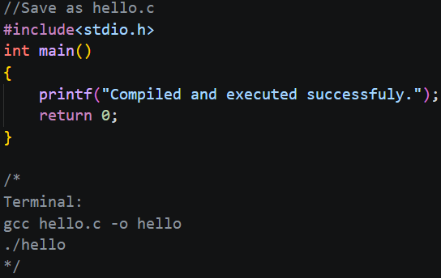

Problem 2: Compile a program from the terminal and display its output.
Solution:
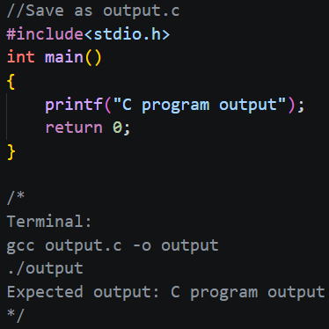
4. printf()
Problem 1: Display an integer, a float and a character using printf().
Solution:
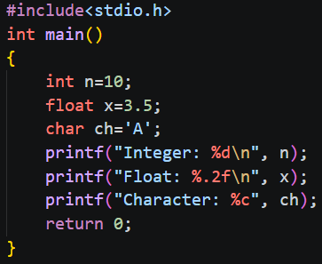

Problem 2: Print a student’s name, age and CGPA in a formatted output.
Solution:
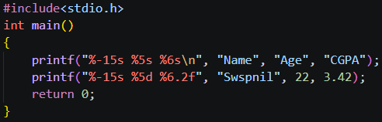

5. scanf()
Problem 1: Input two integers and display their sum.
Solution:
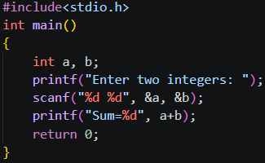

Problem 2: Input a student’s ID, age and CGPA and display them.
Solution:
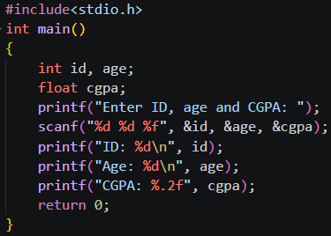

6. Variables in C
Problem 1: Declare variables of different types and calculate the area of a rectangle.
Solution:
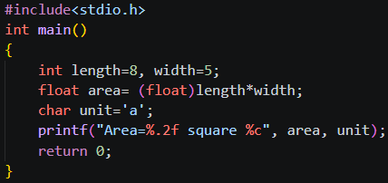

Problem 2: Swap two numbers using a temporary variable.
Solution:
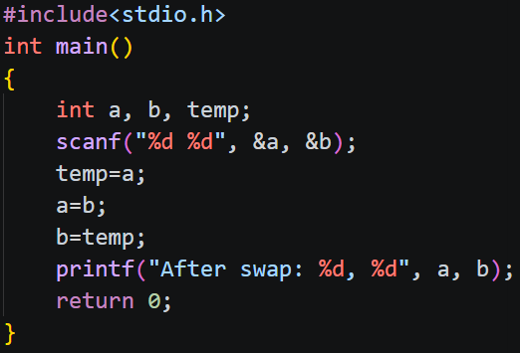

7. Data Types in C
Problem 1: Display the sizes of int, char, float and double using sizeof.
Solution:
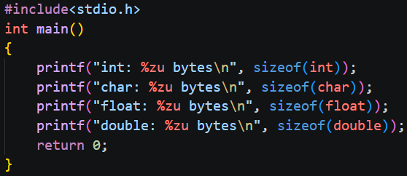

Problem 2: Calculate the area of a circle using a floating-point variable.
Solution:
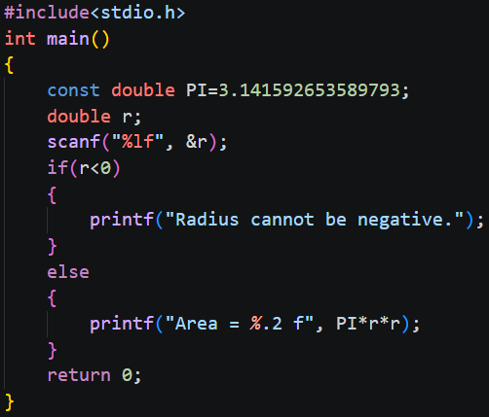
8. Keywords in C
Problem 1: Use int, if, else and return to check whether a number is positive or negative.
Solution:
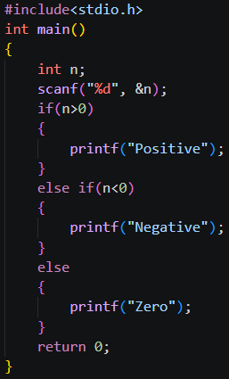

Problem 2: Use the const keyword to store a constant and calculate the area of a square.
Solution:
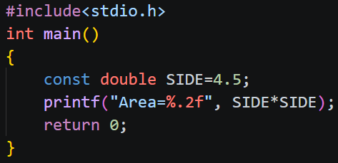

9. C Operators
Problem 1: Input two integers and display their sum, difference, product, quotient and remainder.
Solution:
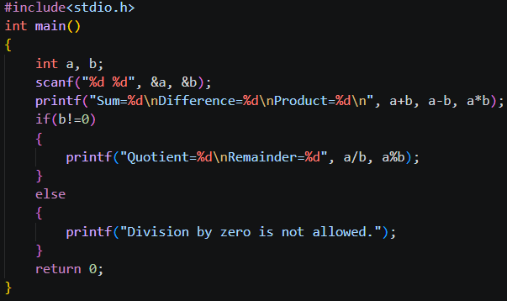

Problem 2: Demonstrate relational, logical, increment and decrement operators.
Solution:
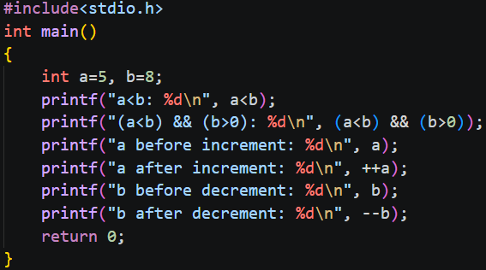
10. C Comments
Problem 1: Calculate the area of a triangle and explain each step using comments.
Solution:
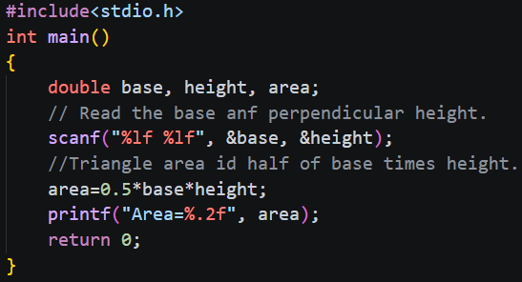

Problem 2: Calculate the average of three numbers using single-line and multi-line comments.
Solution:
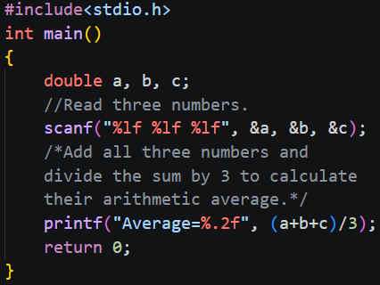
11. C Format Specifiers
Problem 1: Display an integer, character, float, double and string using appropriate format specifiers.
Solution:
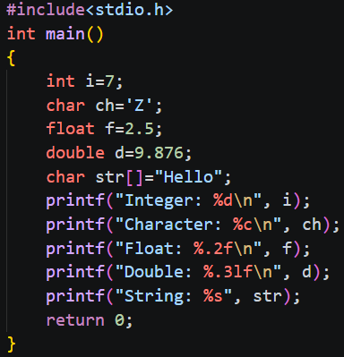

Problem 2: Input two floating-point numbers and display their sum up to two decimal places.
Solution:
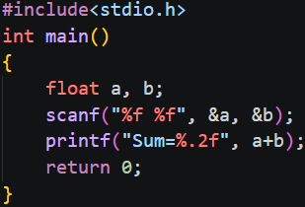

12. C Escape Sequences
Problem 1: Print a student’s information using \n and \t.
Solution:
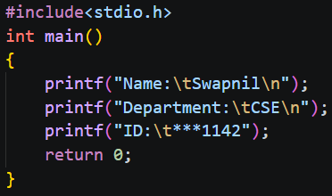

Problem 2: Print the specified name, department, and quoted phrase using escape sequences.
Solution:
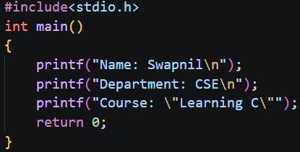

13. ASCII Value in C
Problem 1: Input a character and display its ASCII value.
Solution:
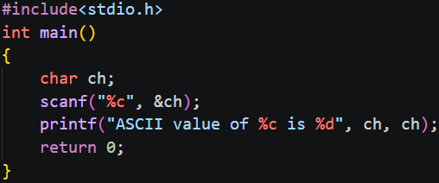

Problem 2: Input an ASCII value and display its corresponding character.
Solution:
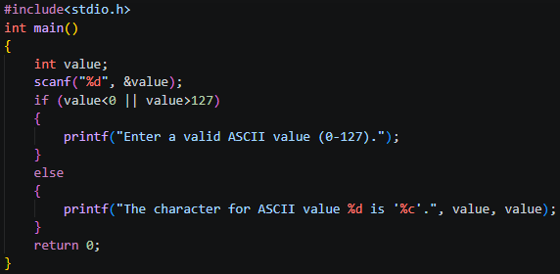

14. Programming Errors in C
Problem 1: Write a program containing a syntax error, identify it and correct it.
Solution:
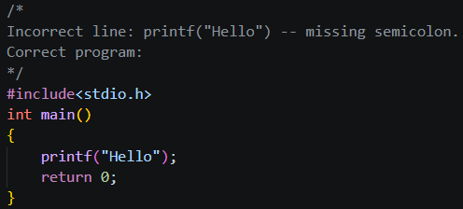

Problem 2: Correct a legal error in a program that calculates the average of three numbers.
Solution:
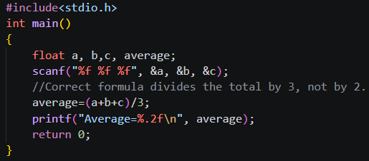

15. If Statement
Problem 1: Check whether a number is positive.
Solution:
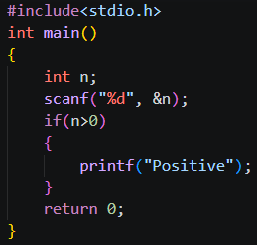

Problem 2: Check whether a number is divisible by 5.
Solution:
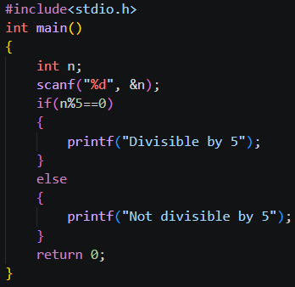

16. If-Else Statement
Problem 1: Check whether a number is even or odd.
Solution:
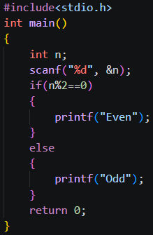

Problem 2: Find the greater of two numbers.
Solution:
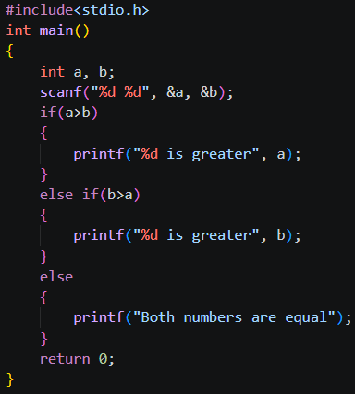
17. If-Else If Ladder
Problem 1: Assign grades based on the specified marks ranges and reject invalid marks.
Solution:
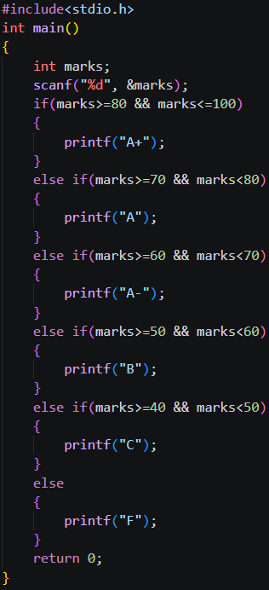

Problem 2: Classify a number as positive, negative, or zero.
Solution:
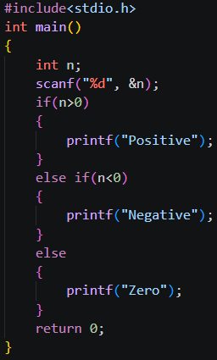

18. Nested If
Problem 1: Find the greatest among three numbers using nested if.
Solution:
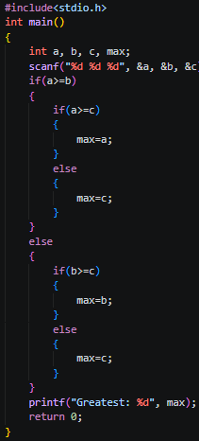
Problem 2: Check voting eligibility and senior citizen discount eligibility at age 60 or above.
Solution:
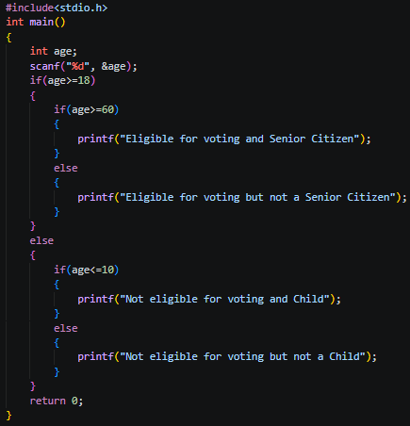

19. Switch Statement

